MOHANA SRIJA PURAM
Computer Science Engineering Student | Aspiring Software Developer
Tenali, Andhra Pradesh, India | +91-8074177416 | purammohanasrija@gmail.com
LinkedIn: linkedin.com/in/mohana-srija-puram-47b628336
GitHub: github.com/purammohanasrija-arch
CAREER OBJECTIVE
Motivated third-year Computer Science Engineering student with a strong foundation in programming, data structures, and full-stack development, and a growing focus on machine learning and AI-driven applications. Seeking opportunities to apply technical and problem-solving skills to real-world projects, deepen ML expertise, and gain industry experience.
EDUCATION
B.Tech in Computer Science and Engineering 2024 – 2028 (Expected)
Vignan's Foundation for Science, Technology and Research | CGPA: 8.15 / 10
Intermediate (12th Grade) 2022 – 2024
Sri Chaitanya Junior College, Tenali | Percentage: 80.3%
SSC (10th Grade) 2021 – 2022
Sri Chaitanya School, Tenali | Percentage: 93.8%
TECHNICAL SKILLS
- Programming Languages: C, Python, Java, DSA,os
- Web Technologies: HTML, CSS, JavaScript, MERN Stack (MongoDB, Express, React, Node.js), Frontend Application Development
- Databases: MySQL, MongoDB (Compass & Shell), Firebase
- Tools & Platforms: VS Code, Git/GitHub, Linux (Ubuntu)
- Areas of Interest: Machine Learning, Artificial Intelligence, AI Agents & LLM Integration
- Apis:openai,gemeni
Ui&ux-figma

Projects:
Autonomous Disaster Response Coordination System Flask | MongoDB | Groq Llama 3
- Developed an AI-powered disaster management platform for real-time disaster analysis and response, featuring AI agents for severity assessment, resource allocation, and route optimization.
- Integrated WhatsApp SOS alerts, live weather monitoring, interactive maps, and a bilingual (English/Telugu) AI chatbot, with OTP-based two-factor authentication and an admin analytics dashboard.
Github link:- https://github.com/purammohanasrija-arch/Autonomous-Disaster-Response-Coordination-System
Deploy:- https://disaster-response-system-rta2.onrender.com/login
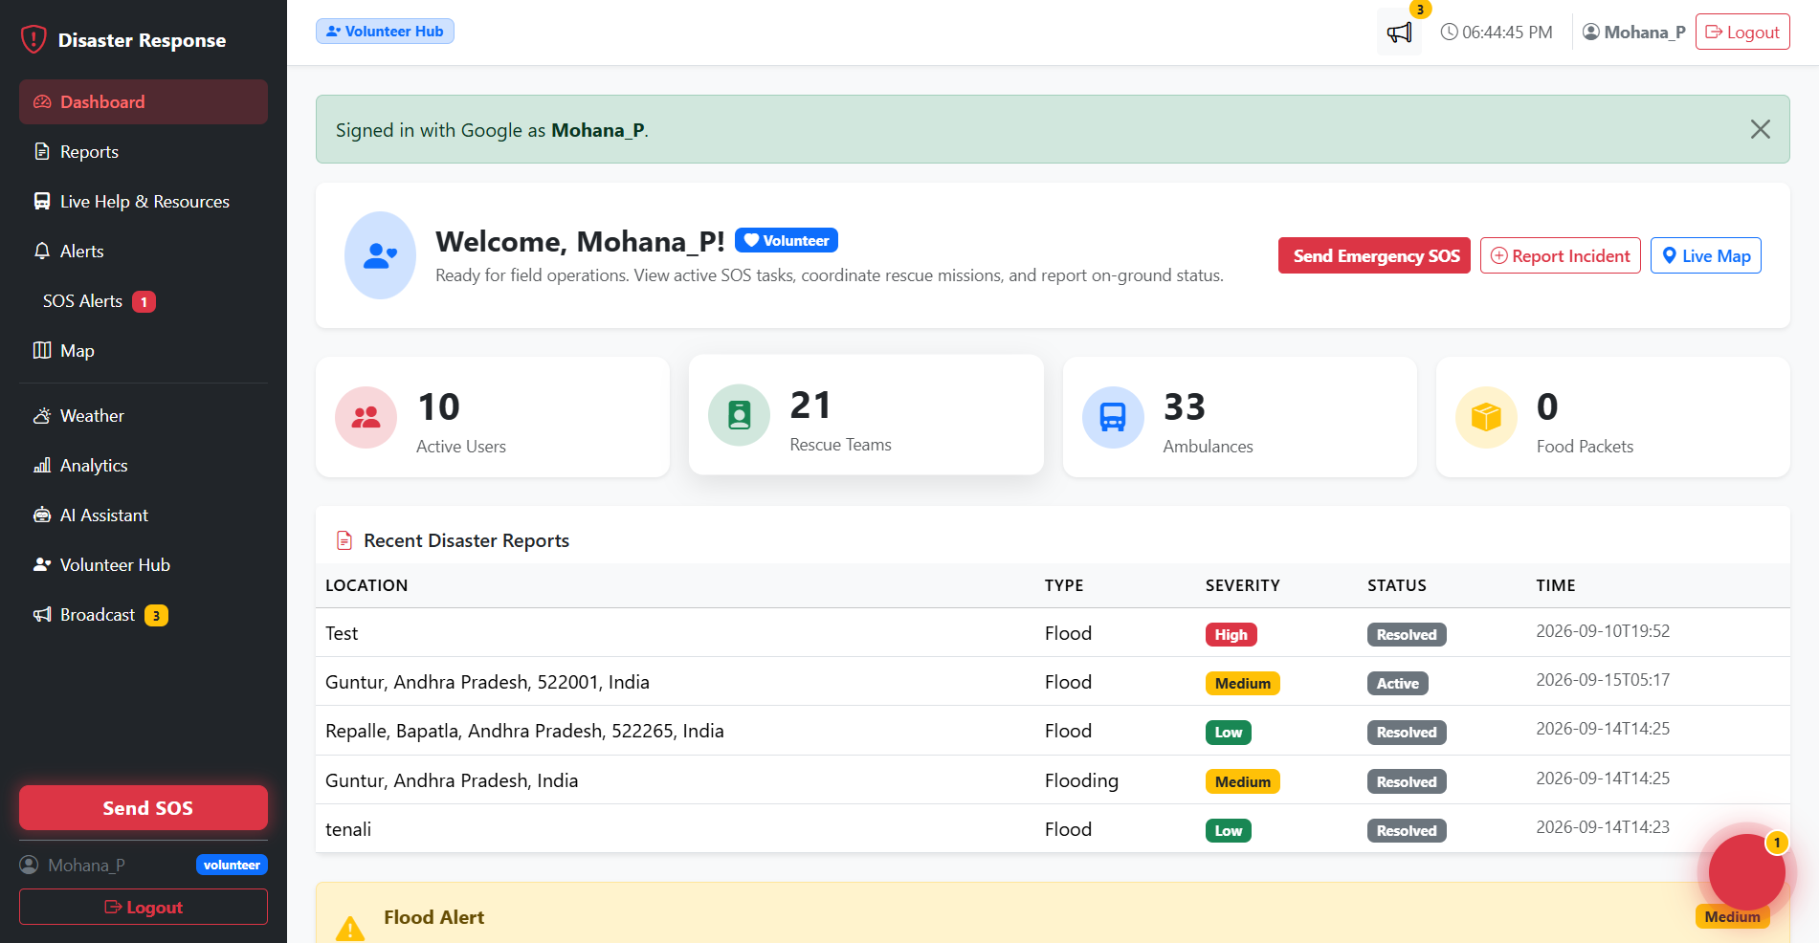
Weather Travel Planner – Full Stack Web Application
MERN Stack (MongoDB, Express, React, Node.js)
- Built a full-stack travel planning application with live weather lookup by city or GPS and a 5-day forecast visualized using Recharts.
- Implemented secure authentication using JWT and bcrypt, with a trip planner module supporting budget calculation and CRUD-based trip storage in MongoDB.
- Developed an AI-powered travel chatbot using the OpenAI API covering 105+ global landmarks, and built a responsive React UI with Framer Motion animations, dark mode, and search history.
Github:- https://github.com/purammohanasrija-arch/Weather-Travel-Planner-/tree/main/Weather-Travel-Planner
Deploy:- https://weather-travel-planner-client-qmsi.onrender.com/
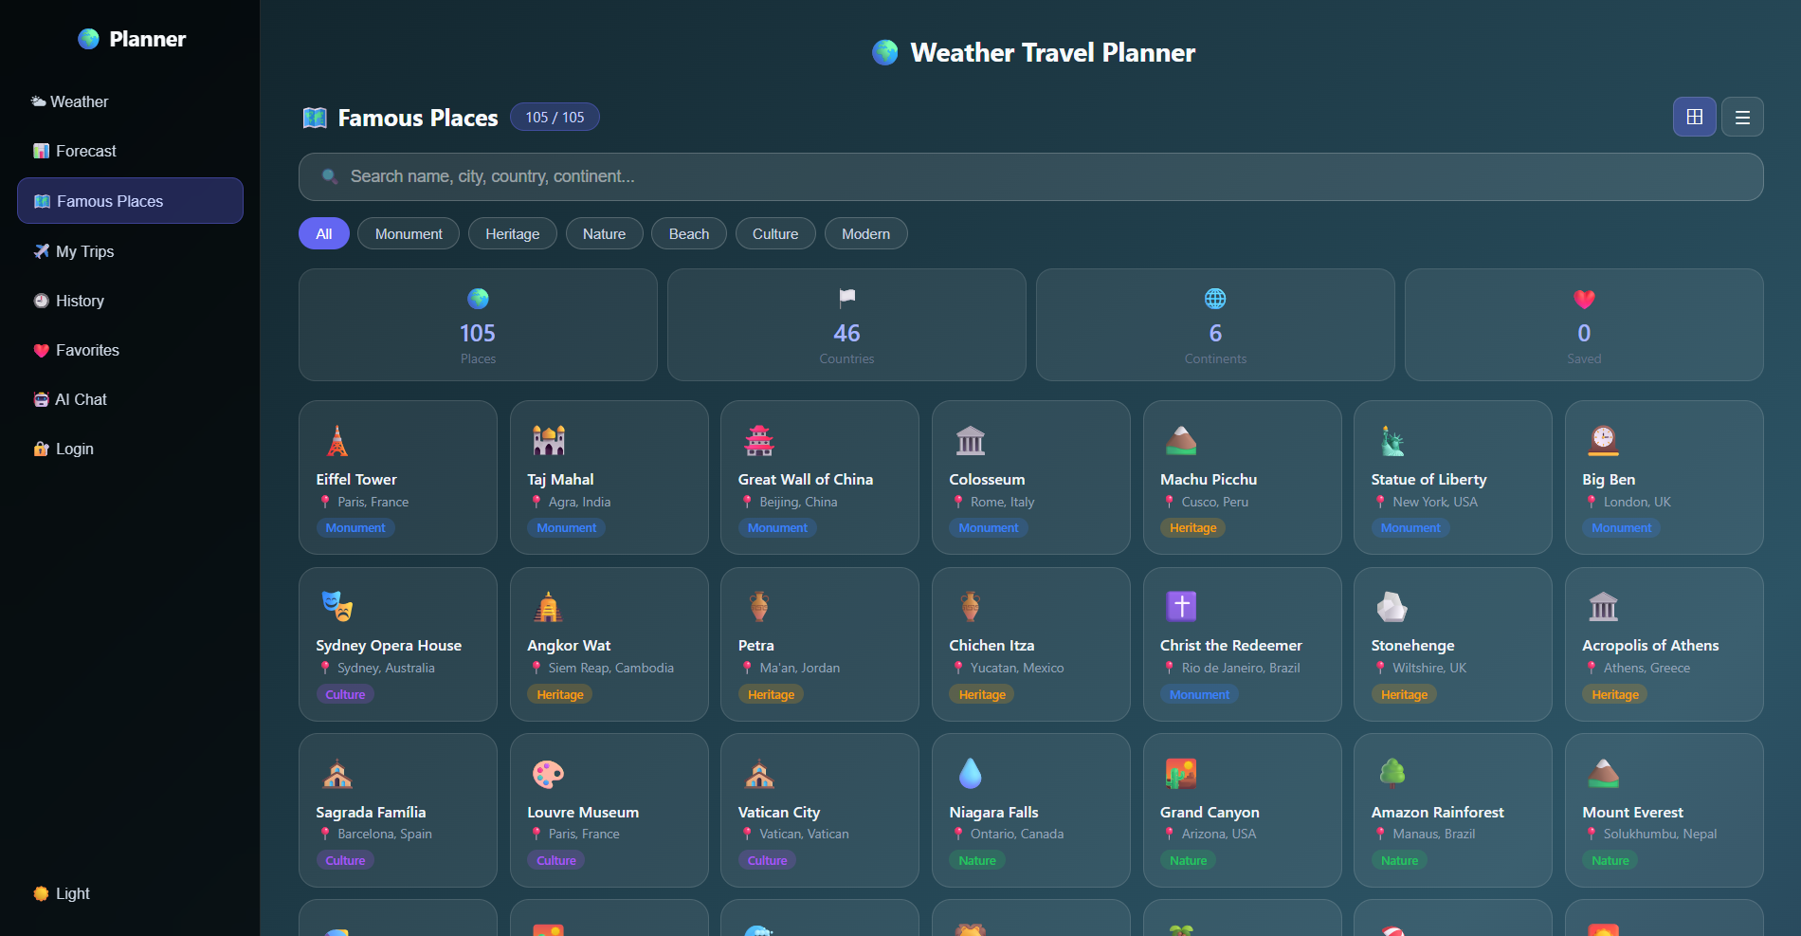

Hamiltonian Cycle Backtracking Visualizer
HTML | CSS | JavaScript
- Developed an interactive web application visualizing the Hamiltonian Cycle problem using backtracking, with live graph rendering, a dynamic adjacency matrix, and a state-space tree.
- Added animation controls, adjustable speed, step-by-step execution logs, and graph presets to support algorithm analysis in a responsive UI.
Depoy link:- https://hamiltonian-cycle.onrender.com
Github:- https://github.com/purammohanasrija-arch/Hamiltonian-Cycle
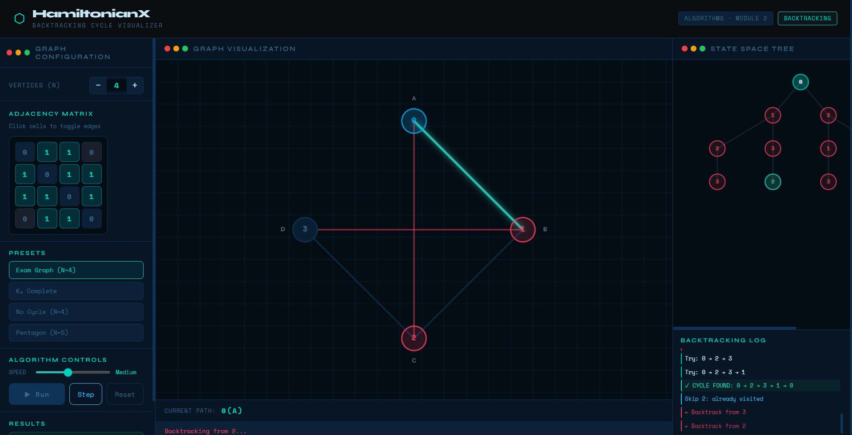

Bridge Crossing Problem Visualizer (Greedy Algorithm)
HTML | CSS | JavaScript
- Built an interactive simulation of the Bridge Crossing problem using a greedy strategy, with real-time animations, timer tracking, and movement logs.
- Added dark/light mode, sound effects, and step-by-step visualization for an enhanced learning experience.
Github:- https://github.com/purammohanasrija-arch/Bridge-Crossing

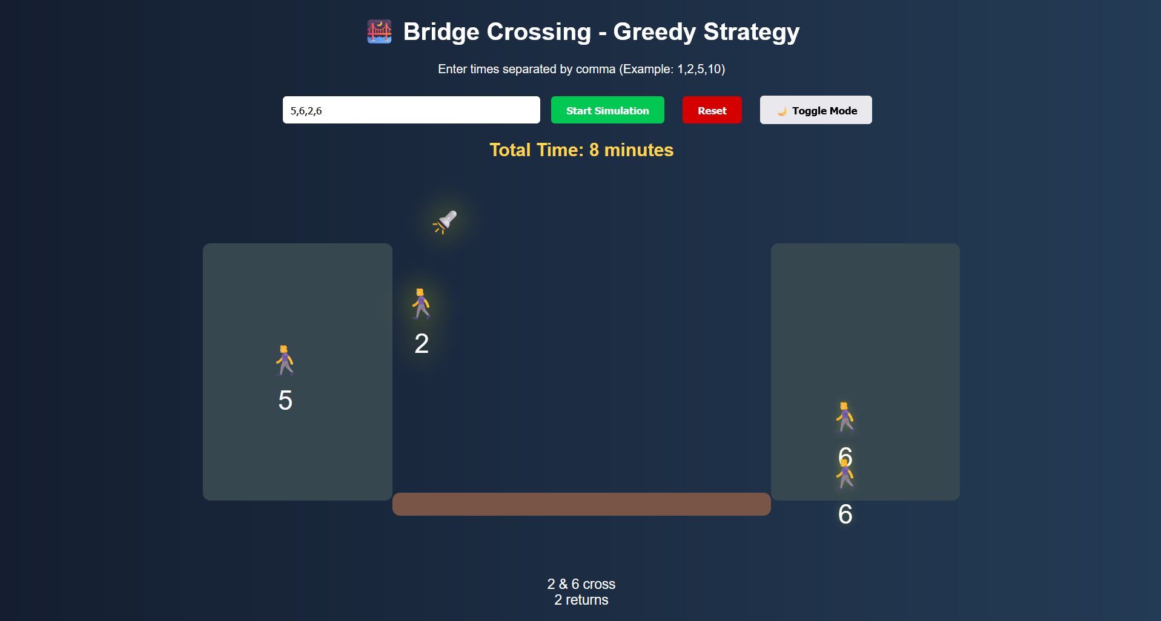
INTERNSHIP EXPERIENCE
Software Development Intern
CodeAlpha(App Development Internship)
• Fitness Tracker App (Python, Flask, SQLite): Built a fitness dashboard with progress tracking, goals, and workout visualizations.
• Language Learning App (Python, Flask, Firebase): Developed a learning platform with flashcards, quizzes, and progress tracking.
• Smart Flashcard Learning Hub (HTML, CSS, JavaScript): Created an interactive flashcard app with animations, CRUD, categories, and localStorage.

Certificate should be stored:
file:///C:/Users/Asus/OneDrive/Desktop/profolio%2022/codealpha/Certificate_Puram%20Mohana%20Srija.pdf

Prodigy InfoTech Internship (Full-Stack Web Development):-
• Task 01: Responsive Landing Page — Build a landing page with a fixed, interactive navigation menu that changes style on scroll or hover using HTML, CSS, and JavaScript.
• Task 02: Stopwatch Web Application — Create a stopwatch app featuring start, pause, reset, and lap time tracking functions using HTML, CSS, and JavaScript.
• Task 03: Tic-Tac-Toe Web Application — Develop an interactive Tic-Tac-Toe game supporting player-versus-player or player-versus-AI modes with win-checking logic.
• Task 04: Personal Portfolio Website — Design a portfolio site showcasing skills, projects, an "About Me" section, background, education, and experience.
• Task 05: Weather App — Build a web page that fetches and displays current weather conditions and temperature from a weather API based on user location.
Certificate should be stored:
file:///C:/Users/Asus/OneDrive/Desktop/profolio%2022/prodigy/Certificate-prodigy.pdf

Unified Mentor Internship (commencing June 2026):-
file:///C:/Users/Asus/OneDrive/Desktop/profolio%2022/unifiedmentor/OfferLetter-unified%20mentor.pdf

CERTIFICATIONS
Cisco:-
- Operating Systems Basics – Cisco Networking Academy- file:///C:/Users/Asus/OneDrive/Desktop/profolio%2022/cisco/Operating_Systems_Basics_certificate_vu-241fa04331-gmail-com_1439e7a0-79de-479f-bbce-02b58740e965%20(1).pdf
- JavaScript Essentials 1 – Cisco Networking Academy-
- file:///C:/Users/Asus/OneDrive/Desktop/profolio%2022/cisco/JavaScript_Essentials_2_certificate_vu-241fa04331-gmail-com_511befb9-3a0f-4f77-81cc-a1d42c0a188d.pdf
- JavaScript Essentials 2 – Cisco Networking Academy- file:///C:/Users/Asus/OneDrive/Desktop/profolio%2022/cisco/JavaScript_Essentials_1_certificate_vu-241fa04331-gmail-com_7454f900-718f-4464-9266-bf52555c08b8.pdf
Python essential – 1 - Cisco Networking Academy- file:///C:/Users/Asus/OneDrive/Desktop/profolio%2022/cisco/_certificate_python%20essential-1.pdf
Python essential – 2 - Cisco Networking Academy- file:///C:/Users/Asus/OneDrive/Desktop/profolio%2022/cisco/_certificate%20-%20python%20essential-2.pdf

NPtel:-
Principles of Management:- file:///C:/Users/Asus/OneDrive/Desktop/profolio%2022/nptel/nptel%20srija.pdf

Unstop:-
Mongodb:-
file:///C:/Users/Asus/OneDrive/Desktop/profolio%2022/unstop/mongodb%20unstop.pdf
jquery:-
file:///C:/Users/Asus/OneDrive/Desktop/profolio%2022/unstop/unstop-jquery.pdf

tata:-

Communica�on Skills:-
file:///C:/Users/Asus/OneDrive/Desktop/profolio%2022/tata/Puram_Srija_5654319-tata.pdf
Introduction to Soft Skills:-
file:///C:/Users/Asus/OneDrive/Desktop/profolio%2022/tata/Puram_Srija_5670223.pdf
Interview Skills:-
file:///C:/Users/Asus/OneDrive/Desktop/profolio%2022/tata/Puram_Srija_5671705.pdf

EXTRA-CURRICULAR & LEADERSHIP
- Coordinator, 62nd National Chess Championship, Vignan University

